**DAILY ONLINE ACTIVITIES SUMMARY**

|  |  |  |  |  |  |  |  |
| --- | --- | --- | --- | --- | --- | --- | --- |
| **Date:** | **20/05/2020** | | | | **Name:** | **JASLINE SHARON TAURO** | |
| **Sem & Sec** | **4th sem, A Section** | | | | **USN:** | **4AL18CS029** | |
| **Online Test Summary** | | | | | | | |
| **Subject** | | **OBJECT ORIENTED CONCEPTS** | | | | | |
| **Max. Marks** | | **30** | | **Score** | | **15** | |
| **Certification Course Summary** | | | | | | | |
| **Course** | **STEPathon-communication skills [ICT ACEDAMY]** | | | | | | |
| **Certificate Provider** | | | **THE HINDU** | **Duration:3 HRS** | | |  |
| **Coding Challenges** | | | | | | | |
| **Problem Statement:** | | | | | | | |
| **Status: DONE** | | | | | | | |
| **Uploaded the report in GitHub** | | | | **YES** | | | |
| **If yes Repository name** | | | |  | | | |
| **Uploaded the report in slack** | | | | **YES** | | | |

Online Test Details: (Attach the snapshot and briefly write the report for the same)

Certification Course Details: (Attach the snapshot and briefly write the report for the same)

Coding Challenges Details: (Attach the snapshot and briefly write the report for the same)

1.ONLINE TEST DETAILS:

Today we had assessment in the subject OBJECT ORIENTED CONCEPTS. It was based on first module of this subject. There were total 30 number of questions of 1 mark each.

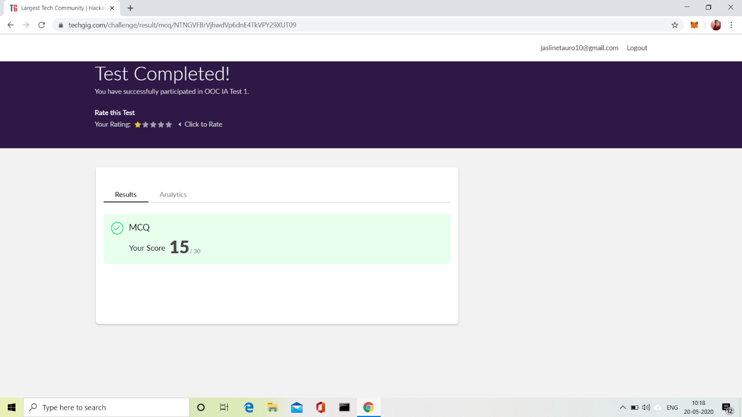

2.CERTIFICATION COURSE DETAILS:

Today I have done 2 certification courses

* **STEPathon-communication skills [ICT ACEDAMY]:**

**This course based on communication skills. Today I have completed the WEEK TWO- 8 videos. This week two session was consisting of some questions based on our listening, Reading, Writing and Grammar skills.**

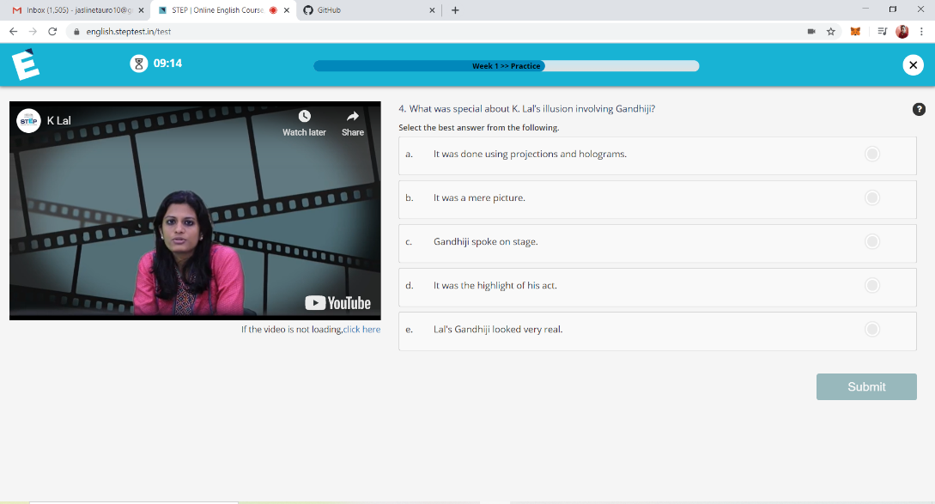

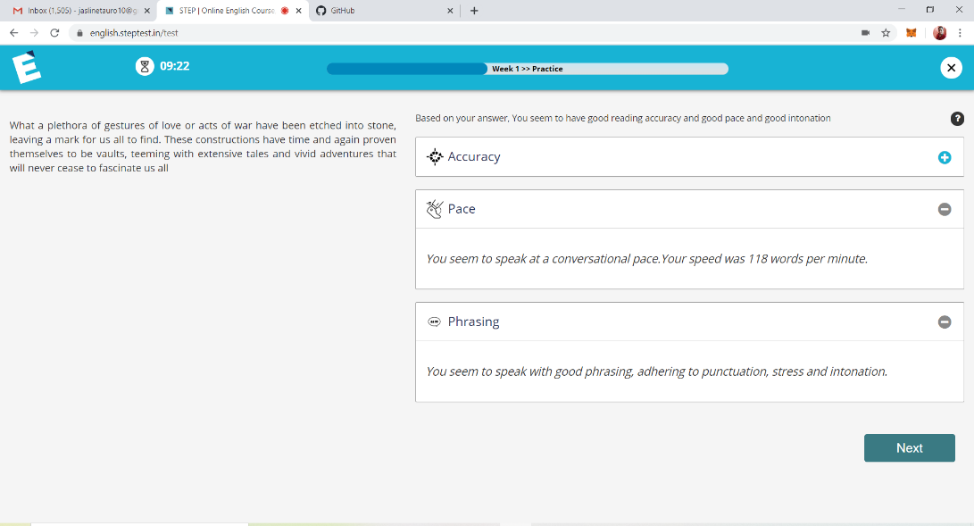

3.CODING CHALLENGES DETAILS:

Problem statement 1:

Solution: Uploaded it in GitHub